

DVTK Design Specification
DVTK Assembly

1.0
2005-06-29
Table of Contents
1 Introduction 4
1.1 Purpose 4
1.2 Scope 4
1.3 Audience 4
1.4 Abbreviations and acronyms 4
1.5 References 4
1.6 History 4
2 DVTK concepts 5
2.1 The Global Overview 5
2.1.1 DVTK Components 5
2.1.2 Core C++ Libraries 6
3 Detail design of DVTK component 7
3.1 Class Description of Setup 7
3.1.1 Initialization 7
3.1.2 Termination 7
4 DVTK.Sessions namespace 8
4.1 Description of DVTK.Sessions classes 8
4.1.1 Session Class 8
4.1.1.1 Properties of Session Class 9
4.1.1.2 Methods of session class 11
4.1.1.3 Definition of Interfaces implemented by session class 12
4.1.2 SessionFactory Class 13
4.1.2.1 Methods of SessionFactory class 13
4.1.3 ScriptSession Class 13
4.1.3.1 Properties of ScriptSession Class 14
4.1.3.2 Methods of ScriptSession class 15
4.1.3.3 Definition of Interfaces implemented by ScriptSession class 17
4.1.4 EmulatorSession Class 18
4.1.4.1 Properties of Emulator Session Class 19
4.1.4.2 Methods of Emulator Session class 20
4.1.4.3 Definition of Interfaces implemented by EmulatorSession class 22
4.1.5 MediaSession Class 23
4.1.5.1 Properties of Media Session Class 23
4.1.5.2 Methods of Media Session class 23
4.1.5.3 Definition of Interfaces implemented by Media Session class 24
4.1.6 Printer class 25
4.1.6.1 Properties of Printer class 25
4.1.6.2 Methods of Printer class 25
4.1.7 SupportedTransferSyntaxSettings class 26
4.1.7.1 Properties of SupportedTransferSyntaxSettings class 26
4.1.7.2 Methods of SupportedTransferSyntaxSettings class 26
4.1.8 Activity Reporter class 26
4.1.8.1 Methods of Activity Reporter class 26
4.1.9 Count Manager class 26
4.1.9.1 Properties of Count Manager class 26
4.1.9.2 Methods of Count Manager class 27
4.1.10 Definition Management Class 27
4.1.10.1 Properties of Definition Management class 28
4.1.10.2 Methods of Definition Management class 28
4.1.10.3 Definition of Interface implemented by Definition File Directory List class 29
4.1.11 Definition File Directory List Class 29
4.1.11.1 Properties of Definition File Directory List class 29
4.1.11.2 Methods of Definition File Directory List class 30
4.1.12 DVT System Settings class 30
4.1.12.1 Properties of DVT System Settings class 30
4.1.12.2 Definition of Interface implemented by DVT System Settings class 31
4.1.13 SUT System Settings Class 31
4.1.13.1 Properties of SUT System Settings class 31
4.1.13.2 Methods of SUT System Settings class 32
4.1.13.3 Definition of Interface implemented by SUT System Settings class 32
4.1.14 Security Settings Class 32
4.1.14.1 Properties of Security Settings class 32
4.1.14.2 Methods of Security Settings class 33
4.1.14.3 Definition of Interface implemented by Security Settings class 33
4.1.15 Serialization Writer class 33
4.1.15.1 Properties of Serialization Writer class 33
4.1.15.2 Methods of Serialization Writer class 34
4.1.16 Serializer class 34
4.1.16.1 Properties of Serializer class 34
4.1.16.2 Methods of Serializer class 34
4.1.16.3 Definition of Interface implemented by Serializer class 37
5 DVTK.Certificates namespace 39
5.1 Certificate Generator class 39
5.1.1 Methods of Certificate Generator class 39
5.1.2 Properties of Certificate Generator class 39
6 DVTK.Security namespace 41
6.1 Certificate class 41
6.1.1 Properties of Certificate class 41
6.2 Credential class 41
6.2.1 Properties of Credential class 41
6.3 Certificate Handling class 42
6.3.1 Properties of Certificate Handling class 42
6.3.2 Methods of Certificate Handling class 42
6.4 Credential Handling class 43
6.4.1 Properties of Credential Handling class 43
6.4.2 Methods of Credential Handling class 43
7 DVTK.Events namespace 45
7.1 ActivityReportEventArgs class 45
7.1.1 Methods of ActivityReportEventArgs class 45
7.1.2 Properties of ActivityReportEventArgs class 45

Introduction

Purpose
This document describes the global and detail design DVTK class library. This is a living document and changes in the design should be laid down in this document. This design document has been written down as a top-level interface specification. The entire interface specification is generated as code-documentation into a .CHM file, which can be referred from DVT installation.

Scope
This library defines main component interface for the DICOM Validation Toolkit. This .NET class library provides DICOM test capabilities to DVT.

Audience
This document is intended for all the implementers in the DVT project. The reader is assumed to have basic DICOM knowledge.

Abbreviations and acronyms
Abbreviation / acronym | Description
AE | Application Entity
Definition File | File containing the DICOM SOP Class description(s).
DVT | DICOM Validation Tool.
Session File | File containing the test session parameters.
User | Person who is implementing the DVTK class library.
IOD | Information Object Definition
VM | Value Multiplicity
VR | Value Representation
DICOM Media File | A File with a content formatted according to the requirements of DICOM Standard Part10. These files shall contain, the File Meta Information and a properly formatted Data Set.
DICOMDIR File | A unique and mandatory DICOM File within a File-set which contains the Media Storage Directory SOP Class. This File is given a single component File ID, DICOMDIR.

References
Reference | Title | Author/Publisher | Document number
VALIDATION |  | M. van Minderhout | XZS 980-000190.00
DESIGNSPEC |  | R. Busbridge  M. van Minderhout | XZS 980-000183.01
PATTERNS | Design Patterns | E. Gamma et al. | ISBN 0201633612
DCM | DICOM standard 2004 | NEMA | PS 3.0-2004
DEFINITION | Definition File Specification | M. van Minderhout | XZS 980-000123.00

History
Version | Date | Author | Description
0.1 | 10 June 2005 | Piyush Bhageriya  Manisha Singla | Initial version
1.0 | 29 June 2005 | Piyush Bhageriya  Manisha Singla | Update for OpenSource release

DVTK concepts
The DVTK library can be used to perform DICOM validation tests. This assembly contains the following namespaces:
- The Sessions namespace defines various session classes. Validation tests are performed within the context of sessions.
- The Events namespace defines events to signal the user (integrating application) about reports generated by the component.
- The Setup class is an entry-point for the component. It is used to ensure that the component is properly initialized and terminated.
- The Security namespace is used to set certificates and credentials used within a test session.
- The Certificates namespace is used to create test certificates.

The Global Overview

GUI (WinForm based C# application)

DVTK (C# dll)

DVTK Data (C# dll)

DVTK Managed Code Adapter (dll)

Attri- Def Script-
Bute lib ing
Group lib All C++ libs
lib …………………

Figure 1 Global diagram for DVT

DVTK Components
The DVTK system consists of:
- DVTK C# Dynamic Link Library – This layer is responsible for managing events/callbacks. It passes session, system, and test specific information to lower layers and to C++ libraries. After executing test scripts the result data is passed to GUI form C++ libraries through this layer.
- DvtkData C# Dynamic Link Library – This layer is responsible for handling result data, generated during/after test processing. It handles the huge amount of data by using XML serializing .NET classes. The result is presented to the user in summary and detail format.
- DVTKManagedCodeAdapter C++ Managed Extensions Dynamic Link Library – This layer mainly handles the marshalling of data to/from C++ libraries (Unmanaged code) to DVTK libraries (Managed code).

Core C++ Libraries
The Core sub-components are:
- DICOM Objects – these are generated by parsing the contents of DICOMScripts or read from Network or File Transfer. These objects can be validated against the definitions. This library refers DICOM manual part 5.
- Session - responsible for parsing the session files (.ses files) and stores the test specific information.
- Definitions – responsible for providing DICOM knowledge to the tool. It parses the loaded definition files and stores the DICOM definitions in memory and providing access to the definition information for other sub-components. This library refers DICOM manual part 3,4 and 6.
- Validation – responsible for performing a validation of the DICOM Objects according to the definition information and the test context as given in session file. This library refers DICOM manual part 5 and 6.
- Scripting – responsible for parsing the DICOMScript files (.ds,.dss,.vbs files). DICOM Objects will be created during script handling.
- Network – responsible for handling the DICOM Upper Layer Protocol (DULP) in terms of the association requests and responses and the finite state machine. This library refers DICOM manual part 8.
- Media – responsible for reading or writing DICOM Objects from / to media files. This library refers DICOM manual part 10.
- Logging – responsible for storing the validation results and other tool status information. These results can be stored in files, returned to the GUI and/or provided to the command window.

Detail design of DVTK component

Class Description of Setup
This public abstract class (Singleton) is not intended design introduced as workaround for converting Managed Extensions for C++ Projects from Pure Intermediate Language to Mixed Mode. This is done because linking with an entry point causes managed code to run during DllMain, which is not safe.

Initialization
public static int Initialize();
This function initialises the component before use. This function is needed to ensure that the C-runtime is correctly started.

Termination
public static int Terminate();
This function terminates the component after use. This function is needed to ensure that the C-runtime is correctly ended.

DVTK.Sessions namespace
Validation tests are performed within the context of sessions. There are three kinds of sessions supported by the component;
- Script Session
- Emulator Session
- Media Session
There is a large collection of interfaces defined within this namespace. These interfaces just provide views on top of the session classes.

Description of DVTK.Sessions classes

Session Class
This class is the base class for all types of session within the DVT. This is the abstract class and implements following interfaces:
- IUserOutput
- IGeneralSessionSettings
- ISessionFileManagement
- IValidationSettings

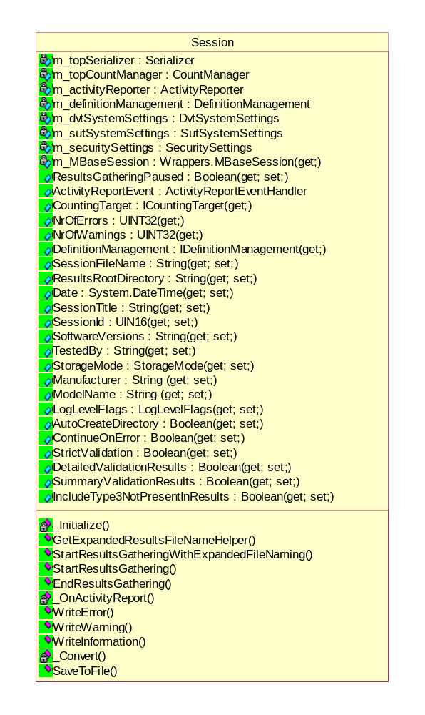
Figure 2 Class diagram of Session

Properties of Session Class

- Pausing the gathering of validation results output
public System.Boolean ResultsGatheringPaused(get; set;)

Argument | Explanation
TRUE | Pause the result gathering.
FALSE | Continue the result gathering.

- Access to counting target
public ICountingTarget CountingTarget(get;)

- Getting the number of errors
public System.UInt32 NrOfErrors(get;)

- Getting the number of warnings
public System.UInt32 NrOfWarnings(get;)

- Access to counting target
public IDefinitionManagement DefinitionManagement(get;)

- Getting/Setting the name of the session file(.ses)
public String SessionFileName(get; set;)

- Getting/Setting the directory used to store results
public String ResultsRootDirectory (get; set;)

- Getting/Setting the date reported in the results
public System.DateTime Date(get; set;)

- Getting/Setting the title of the session
public String SessionTitle(get; set;)

- Getting/Setting the ID of the session
public System.UInt16 SessionId(get; set;)

- Getting/Setting the tester name
public String TestedBy(get; set;)

- Getting/Setting the software version of the SUT
public String SoftwareVersions(get; set;)

- Getting/Setting the storage mode
public StorageMode StorageMode(get; set;)
If the storage mode is set to as-media, DVT will store a received Image Dataset (Group 0008 up to and including Group 7FE0) in a file with the extension .DCM.
The Image Dataset is stored in the .DCM file in the format described in DICOM - part 10. The File Preamble, DICOM Prefix and File Meta Information are added by DVT.

- Getting/Setting the log levels
public LogLevelFlags LogLevelFlags(get; set;)

- Getting/Setting the manufacture of SUT
public String Manufacturer(get; set;)

- Getting/Setting the session property flag
public System.Boolean AutoCreateDirectory(get; set;)
This property determines if a directory is created when this does not yet existing, when writing a Dicom file.

- Getting/Setting the model name of SUT
public String ModelName(get; set;)

- Getting/Setting the session property flag
public System.Boolean ContinueOnError(get; set;)
This property determines of execution should continue when an error has occurred.

- Getting/Setting the validation option
public System.Boolean StrictValidation(get; set;)
The StrictValidation option, when enabled (set true), causes DVT to perform a strict check between the received ACSE and DICOM messages and those programmed (expected) in the DICOMScripts.
If any parameter of the received message does not match that programmed, then DVT reports a FAILED validation and aborts further DICOMScript interpretation.
If the STRICT-VALIDATION flag is disabled (set false), then DVT will WARN the User when a mismatch occurs between received and programmed values.

- Getting/Setting the validation option
public System.Boolean DetailedValidationResults(get; set;)
This property indicates whether DVT should produce Detailed Validation Results or not.

- Getting/Setting the validation option
public System.Boolean SummaryValidationResults(get; set;)
This property indicates whether DVT should produce Summary Validation Results or not.

- Getting/Setting the validation option
public System.Boolean IncludeType3NotPresentInResults(get; set;)
This property indicates whether DVT should include Type 3 attributes in the validation results that are not present in the dataset being validated or not.

Methods of session class

- Initializing
virtual internal void _Initialize();
This function should be called by specialization sub-class from the end of constructor.

- Expanding the results file name
public virtual string GetExpandedResultsFileNameHelper(
string fileName);

- Starting the gathering of validation results output
public void StartResultsGatheringWithExpandedFileNaming(
string fileName);

- Starting the gathering of validation results output
public void StartResultsGathering(string fileName);

- Saving the gathered validation results
public void EndResultsGathering();

- Creating the result object
internal void _OnActivityReport(ActivityReportEventArgs e);

- Writing a user specific error to the output results
public void WriteError(System.String text);

- Writing a user specific warning to the output results
public void WriteWarning(System.String text);

- Writing a user specific information to the output results
public void WriteInformation(System.String text);

- Conversion Dvtk type to Wrappers type
static private Wrappers.StorageMode _Convert(
Dvtk.Sessions.StorageMode value);

- Conversion Wrappers type to Dvtk type
static private Dvtk.Sessions.StorageMode _Convert( Wrappers.StorageMode value);

- Creating the result object
public bool SaveToFile();

Definition of Interfaces implemented by session class

- IuserOutput
void WriteError(System.String text);
void WriteWarning(System.String text);
void WriteInformation(System.String text);

- ISessionFileManagement
bool SaveToFile();

- IGeneralSessionSettings
FileName SessionFileName { get; set; }
Directory ResultsRootDirectory { get; set; }
DateTime Date { get; set; }
String SessionTitle { get; set; }
UInt16 SessionId { get; set; }
String SoftwareVersions { get; set; }
String TestedBy { get; set; }
StorageMode StorageMode { get; set; }
String Manufacturer { get; set; }
String ModelName { get; set; }
LogLevelFlags LogLevelFlags { get; set; }
Boolean AutoCreateDirectory { get; set; }
Boolean ContinueOnError { get; set; }

- IValidationSettings
Boolean StrictValidation { get; set; }
Boolean DetailedValidationResults { get; set; }
Boolean SummaryValidationResults { get; set; }
Boolean IncludeType3NotPresentInResults { get; set; }

SessionFactory Class
This SessionFactory class used to load Sessions from file with extension .SES.

Methods of SessionFactory class

- Loading a session from file
public Session Load(FileName fileName);
This function loads a session from file. It returns a session of type:
- Dvtk.Sessions.ScriptSession
- Dvtk.Sessions.EmulatorSession
- Dvtk.Sessions.MediaSession
The type of session is dynamically determined.

ScriptSession Class
This ScriptSession class used to load Sessions from file with extension .SES.

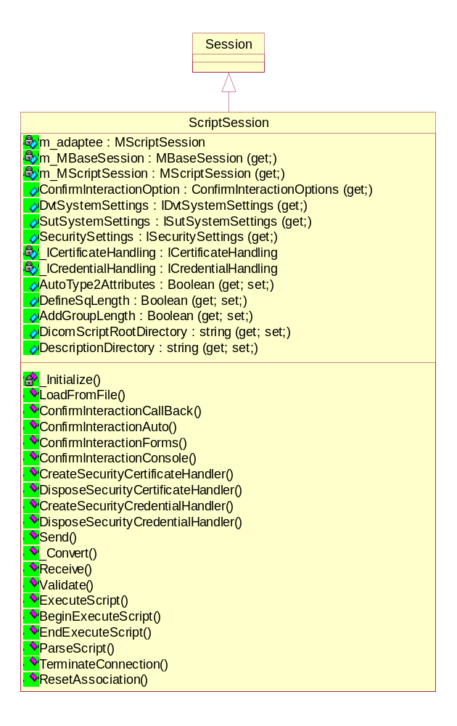
Figure 3 Class diagram of Script Session

Properties of ScriptSession Class

- Getting the base session object
override internal Wrappers.MBaseSession m_MBaseSession(get;)

- Getting the script session object
internal Wrappers. MscriptSession m_MScriptSession(get;)

- Getting the settings specific to the DVT machine node
public IDvtSystemSettings DvtSystemSettings(get;)

- Getting the settings specific to the SUT machine node
public ISutSystemSettings SutSystemSettings(get;)

- Getting the TCP/IP security settings
public ISecuritySettings SecuritySettings(get;)

- Getting/Setting the AutoType2Attributes option
public System.Boolean AutoType2Attributes(get; set;)
The AutoType2Attributes option causes DVT to add any Type 2 Attributes (with a zero-length) to the defined Dataset before sending it to the Product.

- Getting/Setting the DefineSqLength option
public System.Boolean DefineSqLength(get; set;)
The DefineSqLength option is used to make DVT encode explicit length Sequences when sending messages.

- Getting/Setting the AddGroupLength option
public System.Boolean AddGroupLength(get; set;)
The AddGroupLength option is used to have DVT add Group Length attributes to all Groups found in each message sent.

- Getting/Setting the directory serving as root directory from the DICOM Scripts
public String DicomScriptRootDirectory(get; set;)

- Getting/Setting the directory containing instructive and explanatory description files for the scripts
public String DescriptionDirectory(get; set;)

Methods of ScriptSession class

- Initializing
override internal void _Initialize();

- Loading a session from file
static public ScriptSession LoadFromFile(
SessionFileName sessionFileName);

- Delegate implementation
static public void ConfirmInteractionAuto();
This method provides stub callback implementation for results in no interaction with the user. Auto confirms all requests by the application.

- Delegate implementation
static public void ConfirmInteractionForms();
This method provides stub callback implementation for results in a windows message box towards the user.

- Delegate implementation
static public void ConfirmInteractionConsole();
This method provides stub callback implementation for results in a console input request from the user.

- Creating & disposing the certificate handler
public ICertificateHandling CreateSecurityCertificateHandler();
public void DisposeSecurityCertificateHandler();

- Creating & disposing the credential handler
public ICredentialHandling CreateSecurityCredentialHandler();
public void DisposeSecurityCredentialHandler();

- Sending a DICOM message from DVT to SUT
public SendReturnCode Send(DicomMessage dicomMessage);

- Conversion Wrappers type to Dvtk type
private static ReceiveReturnCode _Convert(ReceiveReturnCode receiveReturnCode);
private static SendReturnCode _Convert(SendReturnCode sendReturnCode);

- Receiving a DIMSE message from SUT to DVT
public ReceiveReturnCode Receive(out DicomMessage dicomMessage);

- Receiving a DIMSE or ACSE message from SUT to DVT
public ReceiveReturnCode Receive(out Message message);

- Validating a network related DIMSE message
public bool Validate(
DicomMessage message,
DicomMessage referenceMessage,
ValidationControlFlags validationControlFlags);

- Validating a network related DULP message
public bool Validate(
DulMessage message,
DulMessage referenceMessage,
ValidationControlFlags validationControlFlags);

- Sending a DULP message from DVT to SUT
public SendReturnCode Send(DulMessage message);

- Receiving a DULP message from SUT to DVT
public ReceiveReturnCode Receive(out DulMessage dulMessage);

- Receiving of all 6 ACSE requests / responses
public ReceiveReturnCode Receive(out A_ABORT A_ABORT_Message); public ReceiveReturnCode Receive(out A_ASSOCIATE_AC A_ASSOCIATE_AC_Message);
public ReceiveReturnCode Receive(out A_ASSOCIATE_RJ A_ASSOCIATE_RJ_Message);
public ReceiveReturnCode Receive(out A_ASSOCIATE_RQ A_ASSOCIATE_RQ_Message);
public ReceiveReturnCode Receive(out A_RELEASE_RP A_RELEASE_RP_Message);
public ReceiveReturnCode Receive(out A_RELEASE_RQ A_RELEASE_RQ_Message);

- Executing a DICOMScript(.DS)/DICOMSuperScript (.DSS)
public bool ExecuteScript(string scriptFileName,
bool continueOnError);

- Begin script execution asynchronously
public System.IAsyncResult BeginExecuteScript(
string scriptFileName,
bool continueOnError,
AsyncCallback cb);

- End script execution
public bool EndExecuteScript(IAsyncResult ar);

- Parsing a Script file of type DICOMScript(.DS)/DICOMSuperScript (.DSS)
public Boolean ParseScript(System.String scriptFileName);

- Stopping a script execution
public Boolean TerminateConnection();

- Reset the state of the DULP Finite State Machine
public void ResetAssociation();

Definition of Interfaces implemented by ScriptSession class

  - IDimseMessaging
SendReturnCode Send(DicomMessage dicomMessage);
ReceiveReturnCode Receive(out DicomMessage dicomMessage);
ReceiveReturnCode Receive(out Message message);

  - IDimseValidation
bool Validate(
DicomMessage message,
DicomMessage referenceMessage,
ValidationControlFlags validationControlFlags);

  - IDulMessaging
SendReturnCode Send(DulMessage dulMessage);
ReceiveReturnCode Receive(out DulMessage dulMessage);
ReceiveReturnCode Receive(out A_ABORT A_ABORT_Message);
ReceiveReturnCode Receive(out A_ASSOCIATE_AC A_ASSOCIATE_AC_Message);
ReceiveReturnCode Receive(out A_ASSOCIATE_RJ A_ASSOCIATE_RJ_Message);
ReceiveReturnCode Receive(out A_ASSOCIATE_RQ A_ASSOCIATE_RQ_Message);
ReceiveReturnCode Receive(out A_RELEASE_RP A_RELEASE_RP_Message);
ReceiveReturnCode Receive(out A_RELEASE_RQ A_RELEASE_RQ_Message);

  - IDulValidation
bool Validate(
DulMessage message,
DulMessage referenceMessage,
ValidationControlFlags validationControlFlags);

  - IScriptExecution
string DicomScriptRootDirectory { get; set; }
Boolean ExecuteScript(string dicomScriptFileName,
bool continueOnError);
System.IAsyncResult BeginExecuteScript(string scriptFileName,
bool continueOnError, AsyncCallback cb);
bool EndExecuteScript(IAsyncResult ar) ;
Boolean ParseScript(System.String dicomScriptFileName);
Boolean TerminateConnection();
void ResetAssociation();
String DescriptionDirectory{ get; set; }

  - IDataSetEncodingSettings
Boolean AutoType2Attributes(get; set;)
Boolean DefineSqLength(get; set;)
Boolean AddGroupLength(get; set;)

  - ISecure
ISecuritySettings SecuritySettings { get; }
ICertificateHandling CreateSecurityCertificateHandler( );
ICredentialHandling CreateSecurityCredentialHandler();
void DisposeSecurityCertificateHandler();
void DisposeSecurityCredentialHandler();

  - IConfigurableDvt
IDvtSystemSettings DvtSystemSettings { get; }

  - IConfigurableSut
ISutSystemSettings SutSystemSettings { get; }

EmulatorSession Class
This EmulatorSession class provides emulation for Verification, Storage and Print SOP Classes.
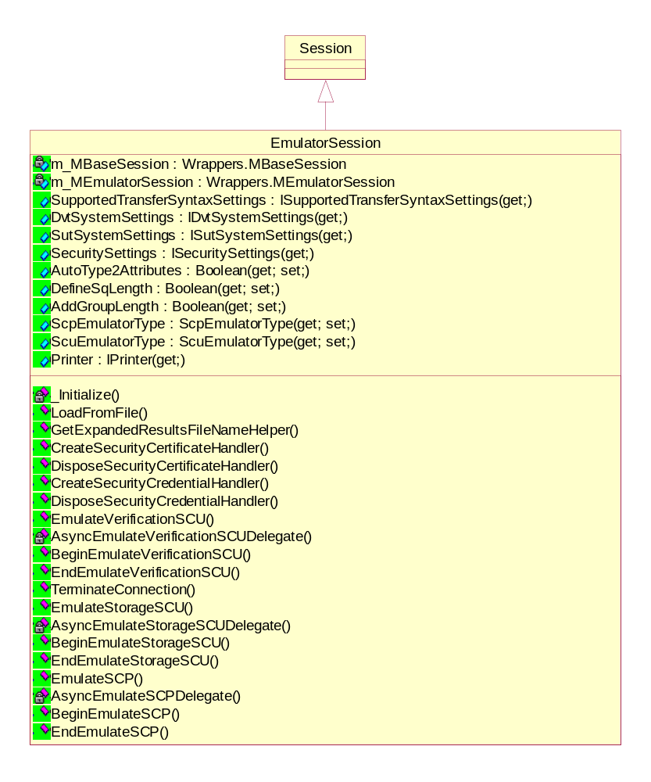
Figure 4 Class diagram of Emulator Session

Properties of Emulator Session Class

- Getting the base session object
override internal Wrappers.MBaseSession m_MBaseSession(get;)

- Getting the emulator session object
internal Wrappers.MemulatorSession m_MEmulatorSession(get;)

- Getting the supported transfer syntaxes settings
public ISupportedTransferSyntaxSettings SupportedTransferSyntaxSettings(get;)

- Getting the settings specific to the DVT machine node
public IDvtSystemSettings DvtSystemSettings(get;)

- Getting the settings specific to the SUT machine node
public ISutSystemSettings SutSystemSettings(get;)

- Getting the TCP/IP security settings
public ISecuritySettings SecuritySettings(get;)

- Getting/Setting the AutoType2Attributes option
public System.Boolean AutoType2Attributes(get; set;)

- Getting/Setting the DefineSqLength option
public System.Boolean DefineSqLength(get; set;)

- Getting/Setting the AddGroupLength option
public System.Boolean AddGroupLength(get; set;)

- Getting/ Setting SCP emulator type that runs in a emulator session
public DvtkData.Results.ScpEmulatorType ScpEmulatorType(get; set;)

- Getting/ Setting SCU emulator type that runs in a emulator session
public DvtkData.Results.ScuEmulatorType ScuEmulatorType(get; set;)

- Getting/Setting the object of Printer
public IPrinter Printer(get;)

Methods of Emulator Session class

- Initializing
override internal void _Initialize();

- Loading a session from file
static public EmulatorSession LoadFromFile(
SessionFileName sessionFileName);

- Delegate implementation
public bool EmulateVerificationSCU();
This method provides stub callback implementation for results in no interaction with the user. Auto confirms all requests by the application.

- Delegate implementation
public System.IAsyncResult BeginEmulateVerificationSCU(
AsyncCallback cb);
This method provides stub callback implementation for results in a windows message box towards the user.

  - Delegate implementation
public bool EndEmulateVerificationSCU(
IAsyncResult ar);
This method provides stub callback implementation for results in a console input request from the user.

- Delegate implementation
public bool EmulateStorageSCU(
MediaFileName[] mediaFileNames,
Boolean multipleAssocations,
Boolean validateOnImport,
System.UInt16 nrOfRepetitions);
This method provides stub callback implementation for results in no interaction with the user. Auto confirms all requests by the application.

- Delegate implementation
public System.IAsyncResult BeginEmulateStorageSCU(
MediaFileName[] mediaFileNames,
Boolean multipleAssocations,
Boolean validateOnImport,
System.UInt16 nrOfRepetitions,
AsyncCallback cb);
This method provides stub callback implementation for results in a windows message box towards the user.

  - Delegate implementation
public bool EndEmulateStorageSCU(
IAsyncResult ar);

- Delegate implementation
public bool EmulateSCP();
This method provides stub callback implementation for results in no interaction with the user. Auto confirms all requests by the application.

- Delegate implementation
public System.IAsyncResult BeginEmulateSCP(
AsyncCallback cb);
This method provides stub callback implementation for results in a windows message box towards the user.

  - Delegate implementation
public bool EndEmulateSCP(IAsyncResult ar);

  - Creating & disposing the certificate handler
public ICertificateHandling CreateSecurityCertificateHandler();
public void DisposeSecurityCertificateHandler();

  - Creating & disposing the credential handler
public ICredentialHandling CreateSecurityCredentialHandler();
public void DisposeSecurityCredentialHandler();

  - Getting the expanded results file
public override string GetExpandedResultsFileNameHelper(string fileName);

  - Terminating emulator execution
public Boolean TerminateConnection();

Definition of Interfaces implemented by EmulatorSession class

  - IEmulatorCommands
Boolean EmulateSCP();
System.IAsyncResult BeginEmulateSCP(AsyncCallback cb);
bool EndEmulateSCP(IAsyncResult ar);
Boolean EmulateStorageSCU(
MediaFileName[] mediaFileNames,
Boolean multipleAssocations,
Boolean validateOnImport,
System.UInt16 nrOfRepetitions);
System.IAsyncResult BeginEmulateStorageSCU(
MediaFileName[] mediaFileNames,
Boolean multipleAssocations,
Boolean validateOnImport,
System.UInt16 nrOfRepetitions,
AsyncCallback cb);
bool EndEmulateStorageSCU(IAsyncResult ar);
Boolean EmulateVerificationSCU();
System.IAsyncResult BeginEmulateVerificationSCU(AsyncCallback cb);
bool EndEmulateVerificationSCU(IAsyncResult ar);
Boolean TerminateConnection();

  - IPrinterSettings
IPrinter Printer { get; }

  - IConfigurableSupportedTransferSyntaxes
ISupportedTransferSyntaxSettings SupportedTransferSyntaxSettings { get; }

  - IValidationSettings
Boolean StrictValidation { get; set; }
Boolean DetailedValidationResults { get; set; }
Boolean SummaryValidationResults { get; set; }
Boolean IncludeType3NotPresentInResults { get; set; }

  - IDataSetEncodingSettings
System.Boolean AutoType2Attributes(get; set;)
System.Boolean DefineSqLength(get; set;)
System.Boolean AddGroupLength(get; set;)

  - ISecure
ISecuritySettings SecuritySettings { get; }
Dvtk.Security.ICertificateHandling CreateSecurityCertificateHandler( );
Dvtk.Security.ICredentialHandling CreateSecurityCredentialHandler();
void DisposeSecurityCertificateHandler();
void DisposeSecurityCredentialHandler();

  - IConfigurableDvt
IDvtSystemSettings DvtSystemSettings { get; }

  - IConfigurableSut
ISutSystemSettings SutSystemSettings { get; }

MediaSession Class
This MediaSession class is used to validate DICOM media files.
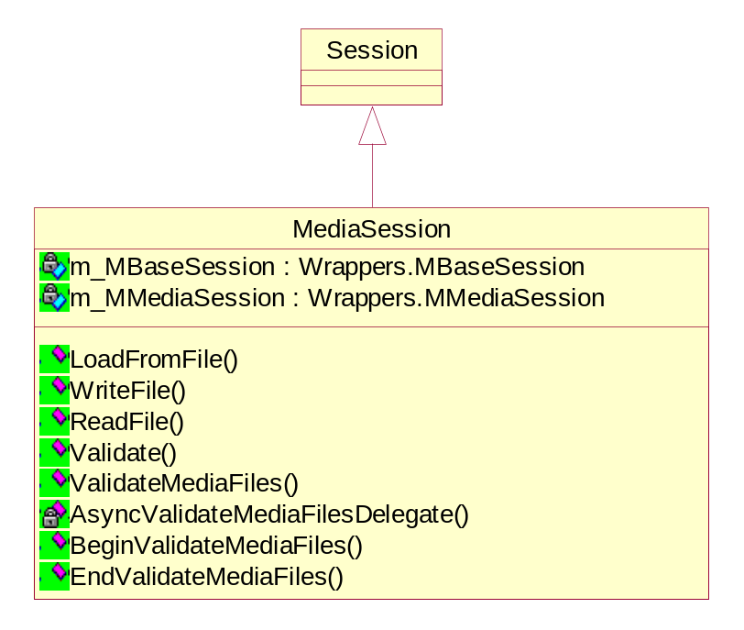
Figure 5 Class diagram of Media Session

Properties of Media Session Class

- Getting the base session object
override internal Wrappers.MBaseSession m_MBaseSession(get;)

- Getting the media session object
internal Wrappers.MMediaSession m_MMediaSession(get;)

Methods of Media Session class

- Loading a session from file
static public MediaSession LoadFromFile(
SessionFileName sessionFileName);

- Writing a DICOM object to a (persistent) Media Storage file
bool WriteFile(DicomFile file, MediaFileName mediaFileName);

- Reading a (persistent) Media Storage file into DICOM object
DicomFile ReadFile(MediaFileName mediaFileName);

  - Validating a media related DICOM object
bool Validate(DicomFile file,
ValidationControlFlags validationControlFlags);

- Validating Media Storage files
Boolean ValidateMediaFiles(System.String[] mediaFileNames);

- Begin validating Media files asynchronously
System.IAsyncResult BeginValidateMediaFiles(
System.String[] mediaFileNames,
AsyncCallback cb);

  - End validating Media files
bool EndValidateMediaFiles(IAsyncResult ar);

Definition of Interfaces implemented by Media Session class

  - IMediaStorage
This interface provides access to commands that read and write media files.
DicomFile ReadFile(MediaFileName mediaFileName);
bool WriteFile(DicomFile file, MediaFileName mediaFileName);

  - IMediaValidation
This interface provides access to commands that validate media related dicom-file objects.
bool Validate(DicomFile file,
ValidationControlFlags validationControlFlags);

  - IMediaValidator
This interface provides validation of a Media Storage File (.DCM or other).
Boolean ValidateMediaFiles(System.String[] mediaFileNames);
System.IAsyncResult BeginValidateMediaFiles(
System.String[] mediaFileNames,
AsyncCallback cb);
bool EndValidateMediaFiles(IAsyncResult ar);

Printer class

Properties of Printer class

- Getting the manufacturer of the printer
public String Manufacturer(get;)

- Getting the manufacturer’s model number of the printer
public String ManufacturerModelName(get;)

- Getting the printer name
public String PrinterName(get;)

- Getting the manufacturer’s serial number of the printer
public String DeviceSerialNumber(get;)

- Getting the time when the printer was last calibrated
public System.DateTime TimeOfLastCalibration(get;)

- Getting the manufacturer’s designation software version of the printer
public String SoftwareVersions(get;)

- Getting the date when the printer was last calibrated
public System.DateTime DateOfLastCalibration(get;)

- Getting the Printer device status
public PrinterStatus Status(get;)

- Getting the additional information about Printer Status
public String StatusInfo(get;)

- Getting the Defined Terms for Printer Status Info
public System.String[] StatusInfoDefinedTerms(get;)

Methods of Printer class

- Applying a new printer status and corresponding status info
public void ApplyStatus(PrinterStatus printerStatus,
System.String statusInfo,
bool sendStatusEvent);

SupportedTransferSyntaxSettings class

Properties of SupportedTransferSyntaxSettings class

- Getting the list of supported transfer syntaxes
public DvtkData.Dul.TransferSyntaxList SupportedTransferSyntaxes (get;)

Methods of SupportedTransferSyntaxSettings class

- Applying supported transfer syntaxes settings
internal SupportedTransferSyntaxSettings(Wrappers.MEmulatorSession adaptee);

- Handler for changes in transfer syntaxes list
private void _TransferSyntaxList_ListChanged(object sender,
System.ComponentModel.ListChangedEventArgs e);

Activity Reporter class
This class is used to report application activities and error/warning messages to the DVT UI.

Methods of Activity Reporter class

  - Conversion Wrappers type to Dvtk type
static private Dvtk.Events.ReportLevel _Convert(
Wrappers.WrappedValidationMessageLevel activityReportLevel);

- Reporting the messages based on report level
public void ReportActivity(
Wrappers.WrappedValidationMessageLevel activityReportLevel,
String message);

Count Manager class
This class is used to count general, validation and user error/warning, which is displayed on the DVT UI.

Properties of Count Manager class

- Getting/Setting the flag for serialization
public System.Boolean SerializeEnabled(get; set;)

- Getting the nr. Of errors
public System.UInt32 NrOfErrors(get;)

- Getting the nr. Of warnings
public System.UInt32 NrOfWarnings(get;)

- Getting the nr. Of validation errors
public System.UInt32 NrOfValidationErrors(get;)

- Getting the nr. Of validation warnings
public System.UInt32 NrOfValidationWarnings(get;)

- Getting the nr. Of general errors
public System.UInt32 NrOfGeneralErrors(get;)

- Getting the nr. Of general warnings
public System.UInt32 NrOfGeneralWarnings(get;)

- Getting the nr. Of user errors
public System.UInt32 NrOfUserErrors(get;)

- Getting the nr. Of user warnings
public System.UInt32 NrOfUserWarnings(get;)

Methods of Count Manager class

- Creating child counting target
public Wrappers.ICountingTarget CreateChildCountingTarget();

- Initializing counting manager
public void Init();

- Incrementing the errors/warnings number
public void Increment(
Wrappers.CountGroup group,
Wrappers.CountType type);

Definition Management Class
A Definition File (.DEF) describes a single DICOM (Meta) SOP Class in terms of the combination of DIMSE Commands and IODs that make up the (Meta) SOP Class.
The combination of DIMSE Commands and IODs is taken from DICOM - parts 3 and 4. The Definition Files provide DVT with the DICOM specific knowledge to enable a validation.
The Definition Files in this version of DVT support the MACRO syntax used in DICOM and describes the conditions under which type 1C and 2C attributes should be present. There are 3 types of definition files used in the DVT:-
  - Standard Definition Files for the most frequently used DICOM (Meta) SOP Classes are provided as part of the DVT release package.
  - Private Definition Files can be made by the User.
  - DVT also provides and uses several Special Definition Files.
This class manages definition files and implements IDefinitionManagement interface.

Properties of Definition Management class

- Getting/Setting the definition file Root Directory
public DefinitionFileRootDirectory DefinitionFileRootDirectory(get; set;)

- Getting the list of currently loaded definition file names
public DefinitionFileName[] LoadedDefinitionFileNames(get;)

- Getting/Setting the Application Entity name for the SUT
public String ApplicationEntityName(get; set;)

- Getting/Setting the Application Entity version for the SUT
public String ApplicationEntityVersion(get; set;)

- Getting the Definition-file directory list
public DefinitionFileDirectoryList DefinitionFileDirectoryList(get;)

Methods of Definition Management class

- Loading a definition file
public Boolean LoadDefinitionFile(
DefinitionFileName definitionFileName);

- Unloading a definition file
public Boolean UnLoadDefinitionFile(
DefinitionFileName definitionFileName);

- Reloading a definition file
public Boolean ReLoadDefinitionFiles();

- Unloading all currently loaded definition files
public void UnLoadDefinitionFiles();

- Retrieving essential information from a definition file
public DefinitionFileDetails GetDefinitionFileDetails(
DefinitionFileName definitionFileName);

- Handler for changes in definition file directory list
private void _DefinitionFileDirectoryList_ListChanged(
object sender,
System.ComponentModel.ListChangedEventArgs e);

Definition of Interface implemented by Definition File Directory List class

  - IDefinitionManagement
This interface manages definitions used by the validation process.
Boolean LoadDefinitionFile(DefinitionFileName definitionFileName);
Boolean UnLoadDefinitionFile(DefinitionFileName definitionFileName);
Boolean ReLoadDefinitionFiles();
void UnLoadDefinitionFiles();
DefinitionFileRootDirectory DefinitionFileRootDirectory(get; set;)
DefinitionFileName[] LoadedDefinitionFileNames(get;)
String ApplicationEntityName(get; set;)
String ApplicationEntityVersion (get; set;)
DefinitionFileDetails GetDefinitionFileDetails(DefinitionFileName definitionFileName);
DefinitionFileDirectoryList DefinitionFileDirectoryList(get;)

Definition File Directory List Class
This class implements the type safe Definition File Directory List.
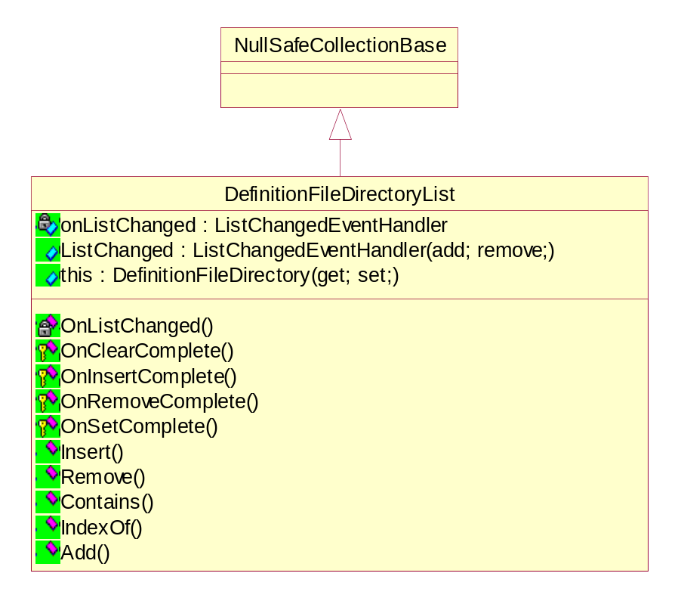
Figure 6 Class diagram of Definition File Directory List

Properties of Definition File Directory List class

- Getting/Setting the definition file Root Directory
public event System.ComponentModel.ListChangedEventHandler ListChanged (add; remove;)

- Getting the list of currently loaded definition file names
public new DefinitionFileDirectory this[int index] (get; set;)

Methods of Definition File Directory List class

- Handler for list change
private void OnListChanged(
System.ComponentModel.ListChangedEventArgs ev);

- Handler for clearing list
protected override void OnClearComplete();

- Handler for inserting object in the list
protected override void OnInsertComplete(int index, object value);

- Handler for removing object in the list
protected override void OnRemoveComplete(int index, object value);

- Handler for setting object in the list
protected override void OnSetComplete(int index, object oldValue, object newValue);

- Inserting object in the list
public void Insert(int index, DefinitionFileDirectory value);

- Removing object in the list
public void Remove(DefinitionFileDirectory value);

- Check for object containing in the list
public bool Contains(DefinitionFileDirectory value);

- Getting the index of object in the list
public int IndexOf(DefinitionFileDirectory value);

- Adding object in the list
public int Add(DefinitionFileDirectory value);

DVT System Settings class
This class represents system parameters for the DICOM Validation Tool (DVT).

Properties of DVT System Settings class

- Getting/Setting the local listen port number
public System.UInt16 Port(get; set;)

- Getting the socket timeout
public System.UInt16 SocketTimeout(get; set;)

- Getting/Setting the Application Entity name for the DVT
AeTitle AeTitle(get; set;)

- Getting/Setting the maximum length of message fragment
public System.UInt32 MaximumLengthReceived(get; set;)

- Getting/Setting the DVT implementation UID
public UID ImplementationClassUid(get; set;)

- Getting/Setting the DVT implementation version name
public System.String ImplementationVersionName(get; set;)

Definition of Interface implemented by DVT System Settings class

  - IDvtSocketParameters
This interface defines TCP/IP socket connection related parameters for the DVT.
UInt16 Port(get; set;)
UInt16 SocketTimeout(get; set;)

  - IDvtDulParameters
This interface defines DUL related parameters for the DVT.
AeTitle AeTitle(get; set;)
UInt32 MaximumLengthReceived(get; set;)
UID ImplementationClassUid(get; set;)
String ImplementationVersionName(get; set;)

SUT System Settings Class
This class represents system parameters for the System Under Test (SUT).

Properties of SUT System Settings class

- Getting/Setting the role that the SUT plays in the validation test
SutRole CommunicationRole(get; set;)

- Getting/Setting the port number which DVT will use for connection
public System.UInt16 Port(get; set;)

- Getting/Setting the hostname which DVT will use for connection
String HostName(get; set;)

- Getting/Setting the Application Entity name for the SUT
AeTitle AeTitle(get; set;)

- Getting/Setting the maximum length of message fragment
public System.UInt32 MaximumLengthReceived(get; set;)

- Getting/Setting the SUT implementation class UID
public UID ImplementationClassUid(get; set;)

- Getting/Setting the SUT implementation version name
public System.String ImplementationVersionName(get; set;)

Methods of SUT System Settings class

  - Conversion Dvtk type to Wrappers type
private Wrappers.SutRole _Convert(SutRole role);

  - Conversion Wrappers type to Dvtk type
private SutRole _Convert(Wrappers.SutRole role);

Definition of Interface implemented by SUT System Settings class

  - ISutSocketParameters
This interface defines TCP/IP socket connection related parameters for the SUT.
SutRole CommunicationRole(get; set;)
UInt16 Port(get; set;)
String HostName (get; set;)

  - ISutDulParameters
This interface defines DUL related parameters for the SUT.
AeTitle AeTitle(get; set;)
UInt32 MaximumLengthReceived(get; set;)
UID ImplementationClassUid(get; set;)
String ImplementationVersionName(get; set;)

Security Settings Class

Properties of Security Settings class

- Getting/Setting the flag for secure socket communication
Boolean SecureSocketsEnabled(get; set;)

- Getting/Setting the protocol password
String TlsPassword(get; set;)

- Getting/Setting the protocol version flags
TlsVersionFlags TlsVersionFlags(get; set;)

- Getting/Setting the flag for using remote certificate
Boolean CheckRemoteCertificate(get; set;)

- Getting/Setting the cipher flags
CipherFlags CipherFlags(get; set;)

- Getting/Setting the flag for caching secure sessions
Boolean CacheTlsSessions(get; set;)

- Getting/Setting the session cache timeout time used by the TLS server
UInt16 TlsCacheTimeout(get; set;)

  - Getting/Setting the credentials file name
FileName CredentialsFileName(get; set;)

- Getting/Setting the certificate file name
FileName CertificateFileName(get; set;)

Methods of Security Settings class

  - Applying the changed contents
void ApplyChangedSocketParameters();

Definition of Interface implemented by Security Settings class

  - IsecuritySettings
This interface provides the access to security settings.
Boolean SecureSocketsEnabled(get; set;)
String TlsPassword(get; set;)
TlsVersionFlags TlsVersionFlags(get; set;)
Boolean CheckRemoteCertificate(get; set;)
CipherFlags CipherFlags(get; set;)
Boolean CacheTlsSessions(get; set;)
UInt16 TlsCacheTimeout(get; set;)
FileName CredentialsFileName(get; set;)
FileName CertificateFileName(get; set;)
void ApplyChangedSocketParameters();

Serialization Writer class
This is serialization target class for the detailed and summary results.

Properties of Serialization Writer class

- Getting the detail stream writer
public StreamWriter DetailStreamWriter(get;)

- Getting the summary stream writer
public StreamWriter SummaryStreamWriter(get;)

Methods of Serialization Writer class

  - Writing starting section of the XML report
public void WriteStartDocument();

  - Opening one element of the XML report
public void WriteStartElement();

  - Writing ending section of the XML report
public void WriteEndDocument();
This method closes any open elements or attributes and puts the writer back in the Start state.

  - Closing one element of the XML report
public void WriteEndElement();

Serializer class
This class is used to serialize all the activities, error and warning messages into a XML report, which is displayed in DVT UI through a style sheet. This class uses intermediate count tables are used during the serialization of directory records.
This counting is performed on the top-level serializer. All serialization of child directory records updates the counts on the top. The parent top serializer generates the TOC for the directory records.

Properties of Serializer class

- Getting/Setting the definition file Root Directory
public bool Paused(get; set;)

- Getting/Setting the definition file Root Directory
public DvtkData.Results.Counters EndCounters (get;)

Methods of Serializer class

  - Constructor
internal Serializer(
Serializer parentSerializer,
Session session,
bool isTopSerializer,
Wrappers.WrappedSerializerNodeType reason);

  - Initializing and starting serializer
private void Init(
int indexOfChildInParentCollection,
Wrappers.WrappedSerializerNodeType reason);

  - Creating child-node for a parent-node
public Wrappers.ISerializationTarget CreateChildSerializationTarget(
Wrappers.WrappedSerializerNodeType reason);

  - Starting/stopping serialization process
public void StartTopSerializer(string fileName);
public void StopTopSerializer();

  - Stopping and checking the child serialization targets
public void EndSerializationTarget();

  - Applying counts at the end of the serialization process
public void AddEndCounts(
System.UInt32 endNrOfGeneralErrors,
System.UInt32 endNrOfGeneralWarnings,
System.UInt32 endNrOfUserErrors,
System.UInt32 endNrOfUserWarnings,
System.UInt32 endNrOfValidationErrors,
System.UInt32 endNrOfValidationWarnings);

  - Conversion Dvtk type to Wrappers type
private void _ApplyTargetFileName(string fileName);

  - Serialize sending messages
public void SerializeSend(DvtkData.Dimse.DicomMessage dicomMessage);
public void SerializeSend(DvtkData.Dul.DulMessage dulMessage);

  - Serialize receiving messages
public void SerializeReceive(DvtkData.Dimse.DicomMessage dicomMessage);
public void SerializeReceive(DvtkData.Dul.DulMessage dulMessage);

  - Serialize validation messages
public void SerializeValidate( DvtkData.Validation.ValidationObjectResult validationObjectResult);
public void SerializeValidate(
DvtkData.Validation.ValidationAbortRq validationAbortRq);
public void SerializeValidate( DvtkData.Validation.ValidationAssociateAc validationAssociateAc);
public void SerializeValidate( DvtkData.Validation.ValidationAssociateRj validationAssociateRj);
public void SerializeValidate( DvtkData.Validation.ValidationAssociateRq validationAssociateRq);
public void SerializeValidate( DvtkData.Validation.ValidationReleaseRq validationReleaseRq);
public void SerializeValidate( DvtkData.Validation.ValidationReleaseRp validationReleaseRp);
public void SerializeValidate(
DvtkData.Validation.ValidationDirectoryRecordResult validationDirectoryRecordResult);

  - Serialize attributes/dataset for display to UI
private void _SerializeDisplay(DvtkData.Results.Display display);
public void SerializeDisplay(DvtkData.Dimse.Attribute attribute);
public void SerializeDisplay(DvtkData.Media.DicomFile dicomFile);
public void SerializeDisplay(DvtkData.Dimse.DicomMessage dicomMessage);
public void SerializeDisplay(DvtkData.Dimse.DataSet dataSet);

  - Serialize DICOM messages
public void SerializeImport(DvtkData.Dimse.DicomMessage dicomMessage);

  - Serialize Media read/write messages
public void SerializeMediaWrite(
System.String fileName,
DvtkData.Media.DicomFile dicomFile);
public void SerializeMediaRead(
System.String fileName,
DvtkData.Media.DicomFile dicomFile);

  - Serialize bytes
public void SerializeBytes(
System.Byte[] bytes, System.String description);

  - Conversion Wrappers type to Dvtk type
private static DvtkData.Activities.ActivityReportLevel _Convert(
Wrappers.WrappedValidationMessageLevel level);

  - Serialize application activities to XML output
public void SerializeApplicationReport(
Wrappers.WrappedValidationMessageLevel activityReportLevel,
System.String message);

  - Create command/dataset serializer
public void SerializeDSCreate(
System.String commandSetRefId,
DvtkData.Dimse.CommandSet commandSet);
public void SerializeDSCreate(
System.String commandSetRefId,
DvtkData.Dimse.CommandSet commandSet,
System.String dataSetRefId,
DvtkData.Dimse.DataSet dataSet);

  - Serialize command/dataset
public void SerializeDSSetCommandSet(
System.String commandSetRefId,
DvtkData.Dimse.CommandSet commandSet);
public void SerializeDSSetDataSet(
System.String dataSetRefId,
DvtkData.Dimse.DataSet dataSet);

  - Delete command/dataset serializer
public void SerializeDSDeleteCommandSet(
System.String commandSetRefId,
DvtkData.Dimse.CommandSet commandSet);
public void SerializeDSDeleteDataSet(
System.String dataSetRefId,
DvtkData.Dimse.DataSet dataSet);

  - Serialize user report
public void SerializeUserReport(
Wrappers.WrappedValidationMessageLevel activityReportLevel,
System.String message);

  - Count errors/warnings
private void SerializeCounts();

Definition of Interface implemented by Serializer class

  - Wrappers.IserializationTarget
This interface is defined in managed code serialization adapter component.
void SerializeSend(DvtkData::Dimse::DicomMessage __gc*);
void SerializeSend(DvtkData::Dul::DulMessage __gc*);
void SerializeReceive(DvtkData::Dimse::DicomMessage __gc*);
void SerializeReceive(DvtkData::Dul::DulMessage __gc*);
void SerializeValidate(DvtkData::Validation::ValidationObjectResult __gc*);
void SerializeValidate(DvtkData::Validation::ValidationAbortRq __gc*);
void SerializeValidate(DvtkData::Validation::ValidationAssociateAc __gc*);
void SerializeValidate(DvtkData::Validation::ValidationAssociateRj __gc*);
void SerializeValidate(DvtkData::Validation::ValidationAssociateRq __gc*);
void SerializeValidate(DvtkData::Validation::ValidationReleaseRp __gc*);
void SerializeValidate(DvtkData::Validation::ValidationReleaseRq __gc*);
void SerializeValidate( DvtkData::Validation::ValidationDirectoryRecordResult __gc*);
void SerializeDisplay(DvtkData::Dimse::Attribute __gc*);
void SerializeDisplay(DvtkData::Media::DicomFile __gc*);
void SerializeDisplay(DvtkData::Dimse::DicomMessage __gc*);
void SerializeDisplay(DvtkData::Dimse::DataSet __gc*);
void SerializeImport(DvtkData::Dimse::DicomMessage __gc*);
void SerializeApplicationReport(
Wrappers::WrappedValidationMessageLevel activityReportLevel,
System::String __gc* pMessage);
void SerializeMediaRead(System::String __gc* fileName, DvtkData::Media::DicomFile __gc*);
void SerializeMediaWrite(System::String __gc* fileName, DvtkData::Media::DicomFile __gc*);
void SerializeBytes(unsigned char managedByteArray __gc[], System::String __gc* pDescription);
void SerializeDSCreate(
System::String __gc* commandSetRefId,
DvtkData::Dimse::CommandSet __gc*);
void SerializeDSCreate(
System::String __gc* commandSetRefId,
DvtkData::Dimse::CommandSet __gc*,
System::String __gc* dataSetRefId,
DvtkData::Dimse::DataSet __gc*);
void SerializeDSSetCommandSet(
System::String __gc* commandSetRefId,
DvtkData::Dimse::CommandSet __gc*);
void SerializeDSSetDataSet(
System::String __gc* dataSetRefId,
DvtkData::Dimse::DataSet __gc*);
void SerializeDSDeleteCommandSet(
System::String __gc* commandSetRefId,
DvtkData::Dimse::CommandSet __gc*);
void SerializeDSDeleteDataSet(
System::String __gc* dataSetRefId,
DvtkData::Dimse::DataSet __gc*);
ISerializationTarget __gc* CreateChildSerializationTarget( Wrappers::WrappedSerializerNodeType reason);
void EndSerializationTarget();
void AddEndCounts(
System::UInt32 endNrOfGeneralErrors,
System::UInt32 endNrOfGeneralWarnings,
System::UInt32 endNrOfUserErrors,
System::UInt32 endNrOfUserWarnings,
System::UInt32 endNrOfValidationErrors,
System::UInt32 endNrOfValidationWarnings);
__property System::Boolean get_Paused(void);
__property void set_Paused(System::Boolean);
__property DvtkData::Results::Counters __gc* get_EndCounters(void);

DVTK.Certificates namespace

Certificate Generator class
This class generates certificates in a specified certificate file.

Methods of Certificate Generator class

  - Generating a certificate with the current settings
public void Generate();

  - Building subject name used in certificate generation
static private System.String BuildSubjectName(
System.String commonName,
System.String organizationalUnit,
System.String organization,
System.String locality,
System.String state,
System.String country);

Properties of Certificate Generator class

- Getting/Setting the certificate file to be generated
public System.String CertificateFile(get; set;)

- Getting/Setting the certificate file name
public System.String CommonName(get; set;)
This Common name must be identical to the fully qualified domain name of the server for which you are requesting a certificate. Do not include the protocol specifier (http://) or any port numbers or pathnames in the common name. Do not use use wildcards such as * or ?, and do not use an IP address.

- Getting/Setting the name of the country
public System.String Country(get; set;)

- Getting/Setting the name of the locality
public System.String Locality(get; set;)
- Getting/Setting the name of the organization
public System.String Organization(get; set;)

- Getting/Setting the name of the department/group that will be using the secure server
public System.String OrganizationalUnit(get; set;)

- Getting/Setting the name of the state in which organization has its head office
public System.String State(get; set;)

- Getting/Setting the credentials file name
public System.String CredentialsFile(get; set;)

- Getting/Setting the password for the signer's credentials file
public System.String CredentialsFilePassword(get; set;)

- Getting/Setting the Private Key file to be generated
public System.String PrivateKeyFile(get; set;)

- Getting/Setting the private key password
public System.String PrivateKeyPassword(get; set;)

- Getting/Setting the nr. of bits use in the signing algorithm
public System.Int32 SignatureKeyLength(get; set;)

- Getting/Setting the Signature Algorithm
public SignatureAlgorithm SignatureAlgorithm(get; set;)

- Getting/Setting the beginning date for the validity of the certificate
public System.DateTime ValidFromDate(get; set;)

- Getting/Setting the ending date for the validity of the certificate
public System.DateTime ValidToDate(get; set;)

- Getting/Setting the flag for self signing
public System.Boolean SelfSign(get; set;)

DVTK.Security namespace
This namespace provides access to information of the security item. The security item may be either a certificate or credential.

Certificate class
This class represents certificate security item.

Properties of Certificate class

- Getting the effective date
public object EffectiveDate(get;)

- Getting the expiration date
public object ExpirationDate(get;)

- Getting the name of the issuer
System.String Issuer(get;)

- Getting the serial number of the certificate
System.String SerialNumber(get;)

- Getting the name of the signature algorithm
public System.String SignatureAlgorithm(get;)

- Getting the signature key length
public System.Int32 SignatureKeyLength(get;)

- Getting the subject of certificate
public System.String Subject(get;)

- Getting the certificate version
public System.Int32 Version(get;)

Credential class
This class represents credential security item.

Properties of Credential class

- Getting the effective date
public object EffectiveDate(get;)

- Getting the expiration date
public object ExpirationDate(get;)

- Getting the name of the issuer
System.String Issuer(get;)

- Getting the serial number of the credential
System.String SerialNumber(get;)

- Getting the name of the signature algorithm
public System.String SignatureAlgorithm(get;)

- Getting the signature key length
public System.Int32 SignatureKeyLength(get;)

- Getting the subject of credential
public System.String Subject(get;)

- Getting the credential version
public System.Int32 Version(get;)

Certificate Handling class
This class handles certificates. The handling involves loading, adding, removing and saving certificates to the file. It also verifies the changes in certificates.

Properties of Certificate Handling class

- Getting the list of certificates
public System.Collections.ArrayList Certificates(get;)

- Getting/Setting the certificate file name
public System.String FileName(get; set;)

- Getting/Setting the certificate password
public System.String Password(get; set;)

Methods of Certificate Handling class

  - Importing certificate from an other file
public void ImportCertificateFromOtherFile(
System.String fileName, System.String password);

  - Loading/removing certificates to/from file
public System.Boolean RemoveCertificatesFromFile(
params System.UInt32[] indexes);
public void LoadCertificateFile(
System.String fileName, System.String password);

  - Verifying the changes in certificate file
private System.Boolean _CheckForChanges(
out System.Boolean sessionChanged,
out System.Boolean certificateFileChanged);
public System.Boolean VerifyChanges(
out System.String verificationMessage);

  - Saving certificate to the file
public System.Boolean SaveCertificateFile(
out System.String verificationMessage);
public System.Boolean ForcedSaveCertificateFile();
private System.Boolean _SaveCertificateFile(
System.Boolean forcedSave,
out System.String verificationMessage);
In first method, the file will not be saved if the changes are not valid.
Second function saves certificate to file even if the changes are not valid.

Credential Handling class
This class handles credentials. The handling involves loading, adding, removing and saving credentials to the file. It also verifies the changes in credentials.

Properties of Credential Handling class

- Getting the list of credentials
public System.Collections.ArrayList Credentials(get;)

- Getting/Setting the credential file name
public System.String FileName(get; set;)

- Getting/Setting the credential file name
public System.String Password(get; set;)

Methods of Credential Handling class

  - Generating a certificate with the current settings
private void _RefreshCredentialListFromFile();

  - Importing credential from an other file
public void ImportCredentialFromOtherFile(
System.String fileName, System.String password);

  - Loading/removing credentials to/from file
public System.Boolean RemoveCredentialFromFile(
params System.UInt32[] indexes);
public void LoadCredentialFile(
System.String fileName, System.String password);

  - Verifying the changes in credential file
private System.Boolean _CheckForChanges(
out System.Boolean sessionChanged,
out System.Boolean credentialFileChanged);
public System.Boolean VerifyChanges(
out System.String verificationMessage);

  - Saving credential to the file
public System.Boolean SaveCredentialFile(
out System.String verificationMessage);
public System.Boolean ForcedSaveCredentialFile();
private System.Boolean _SaveCredentialFile(
System.Boolean forcedSave,
out System.String verificationMessage);
In first method, the file will not be saved if the changes are not valid.
Second function saves credential to file even if the changes are not valid.

DVTK.Events namespace

ActivityReportEventArgs class
This class provides the data for the events.
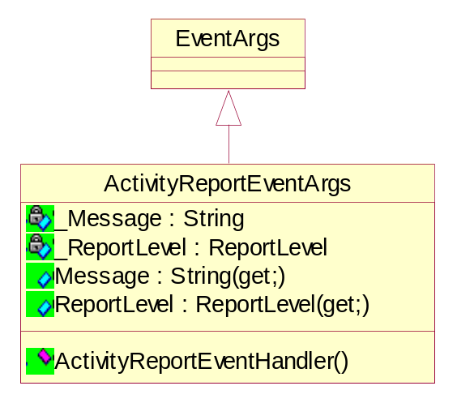
Figure 7 Class diagram of ActivityReportEventArgs

Methods of ActivityReportEventArgs class

  - Delegate
public delegate void ActivityReportEventHandler(object sender, ActivityReportEventArgs e);
This method represents the method that handles the Activity Report Events. Users may register a callback to listen for this event.

Properties of ActivityReportEventArgs class

- Getting the message
public string Message(get;)

- Getting the Report level of activities reported by the DVT
public ReportLevel ReportLevel(get;)

